**CENWP-OD-B 11 September 2023**

**MEMORANDUM FOR THE RECORD**

**SUBJECT: 23BON089 MFR AFF Valve 15 Salmonid Mortalities**

On the afternoon of 08 September, Columbia River Inter-Tribal Fish Commission (CRITFC) Biologists notified Bonneville Project Biologists of two salmonid mortalities found on the Valve 15 trash rack in the Adult Fish Facility (AFF). The fish were all scanned for PIT tags, inspected, and returned to the river.

1. Species – Salmonid (*Oncorhynchus spp)*
2. Origin – Unknown
3. Length – in descending order of the picture 78.7 cm, 71.1 cm
4. Marks and tags – Adipose fin clip, no PIT tag
5. Marks and Injuries found on carcass – Crater lesions, General decay.
6. Cause and Time of Death – Unknown
7. Future and Preventative Measures – None

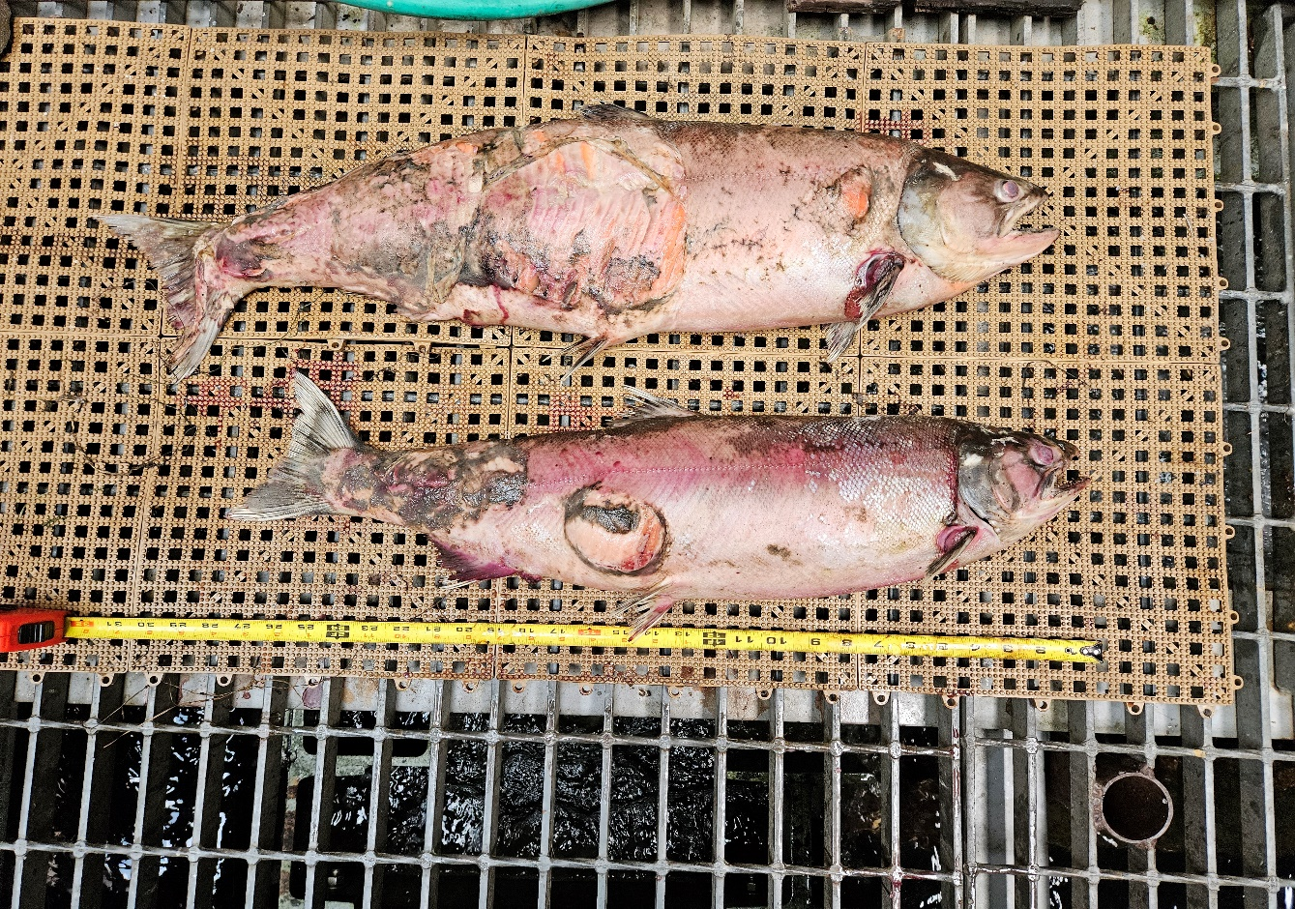

Sincerely,

Bonneville Project Fisheries